**Introduction**

Our project is designed to produce a model that classifies traffic signs to their classes.

For this purpose, we used logistic regression in the first step because it is a classification problem and with Softmax because it is more than two classes.

In the second step we used a neural network with one hidden layer and a Relu activation function in order to achieve a better result in the percentage of accuracy but surprisingly the results were less good than the model of the first stage (the simple logistic regression model).

In the third step we increased the amount of neurons of the hidden layer and the results were not as expected.

In the fourth step we added another hidden layer to the grid and we have not yet improved the model.

In the last step we used the "Adam optimizer" algorithm and we were able to achieve better results.

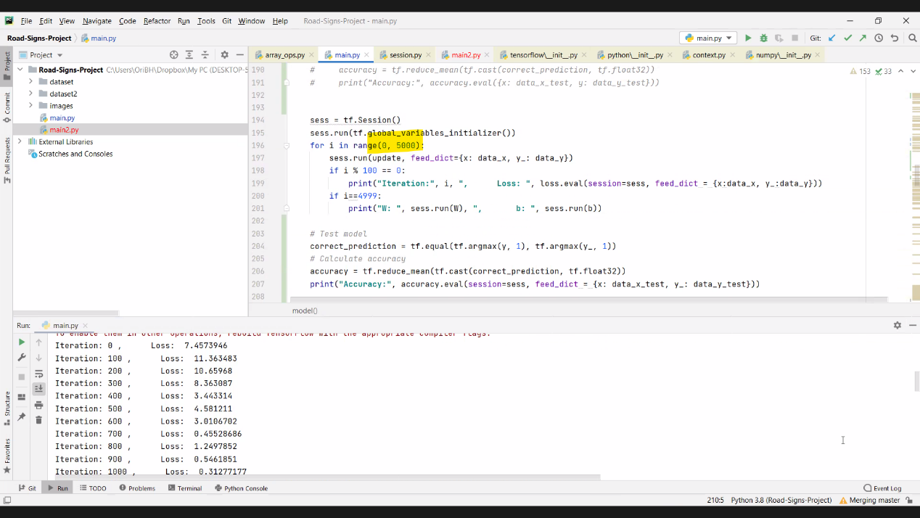**Logistic regression**

The accuracy of the test with 5000 iterations is 0.94930875

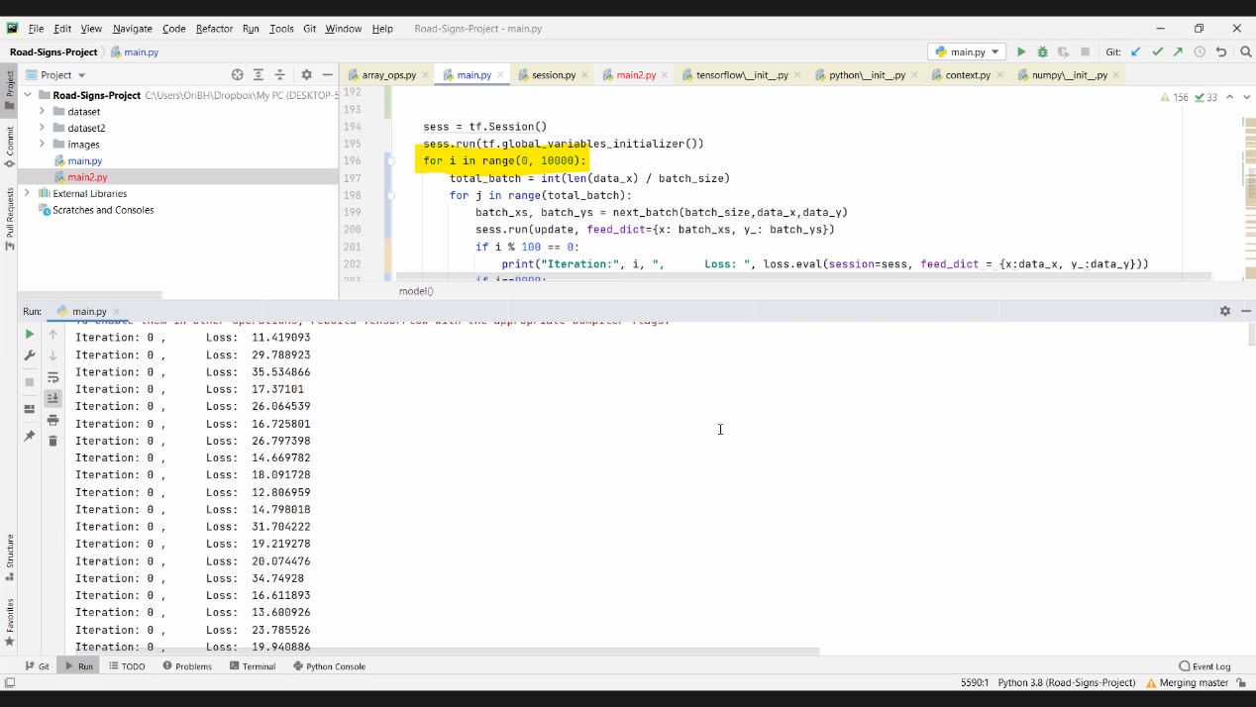

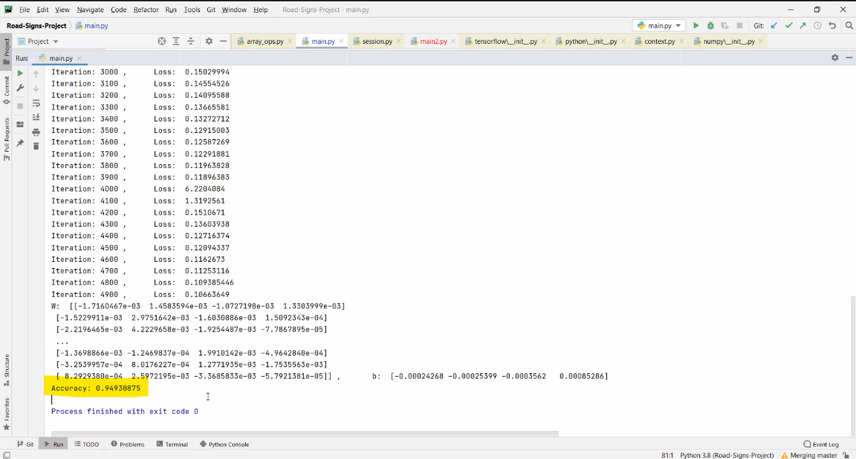

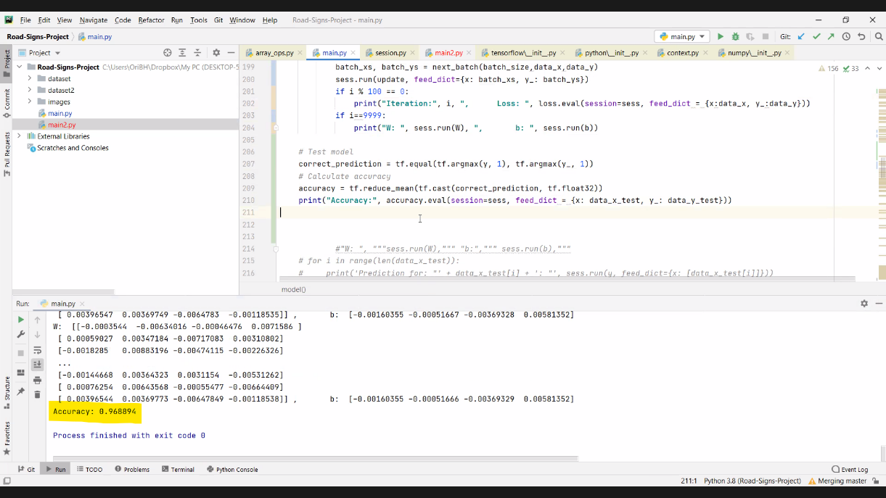The accuracy of the test with 10000 iterations is 0.968894

**Neural Network with one hidden layer**

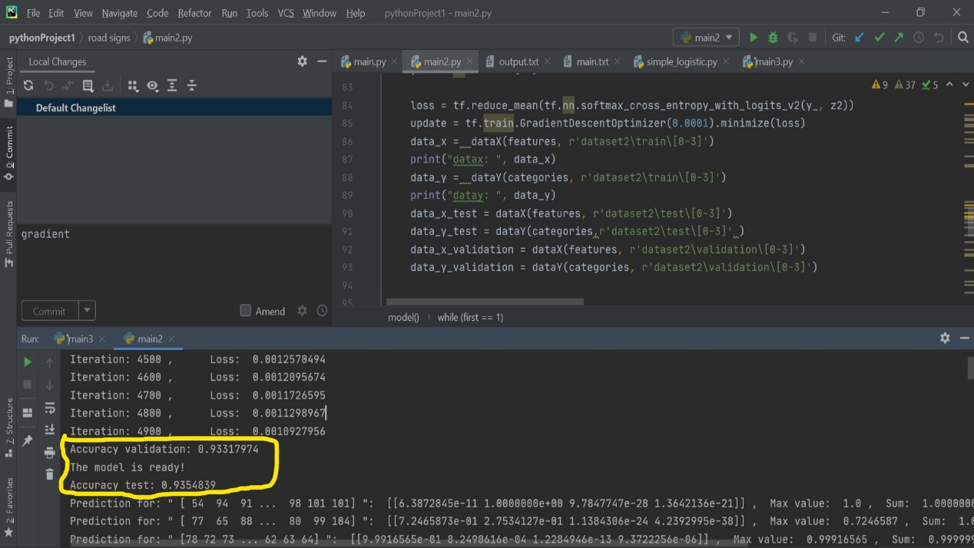

The result with Neural Network with one hidden layer (100 neurons) and Gradient Descent algorithm after 5000 iterations.

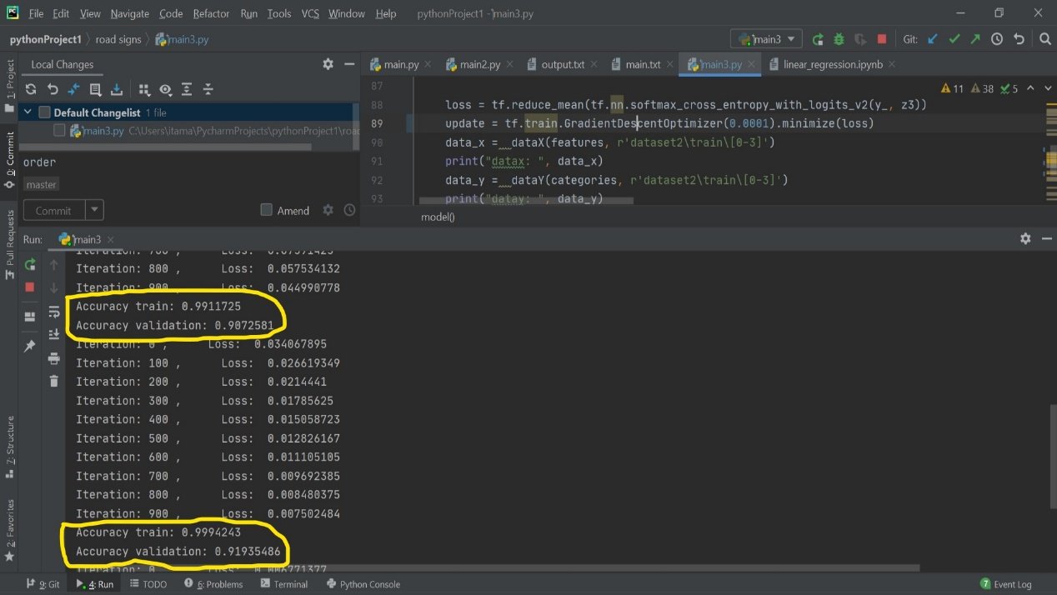**Neural Network with two hidden layers**

The result with Neural Network with two hidden layers (200 neurons in the first layer and 100 neurons in the second layer) and Gradient Descent algorithm after 5000 iterations.

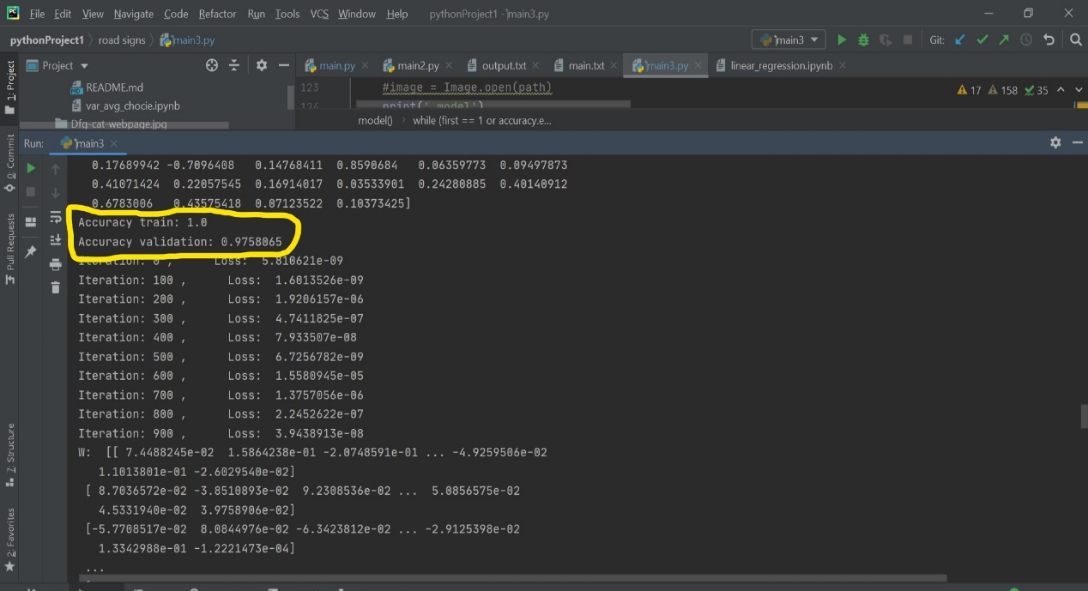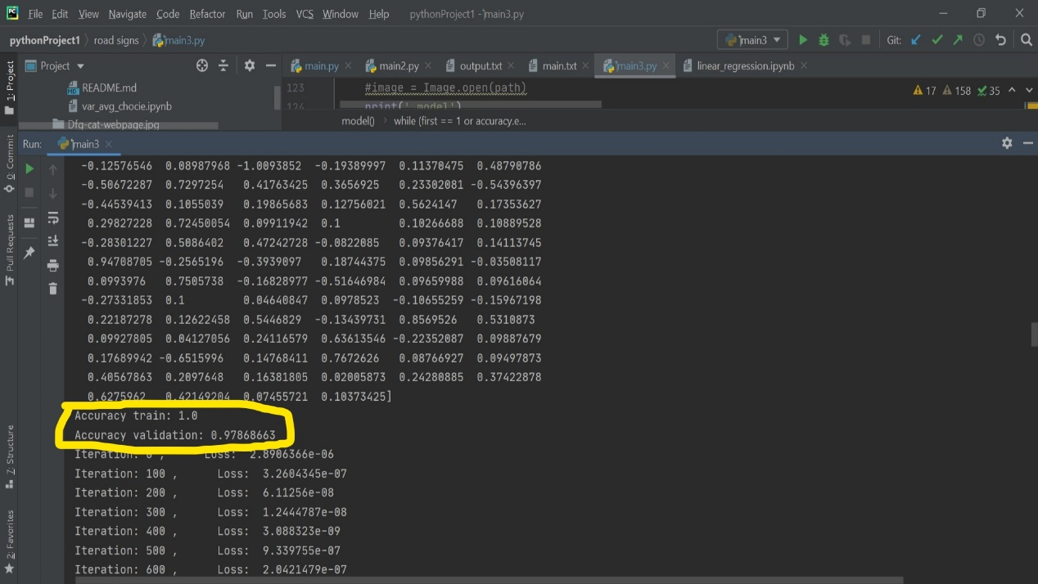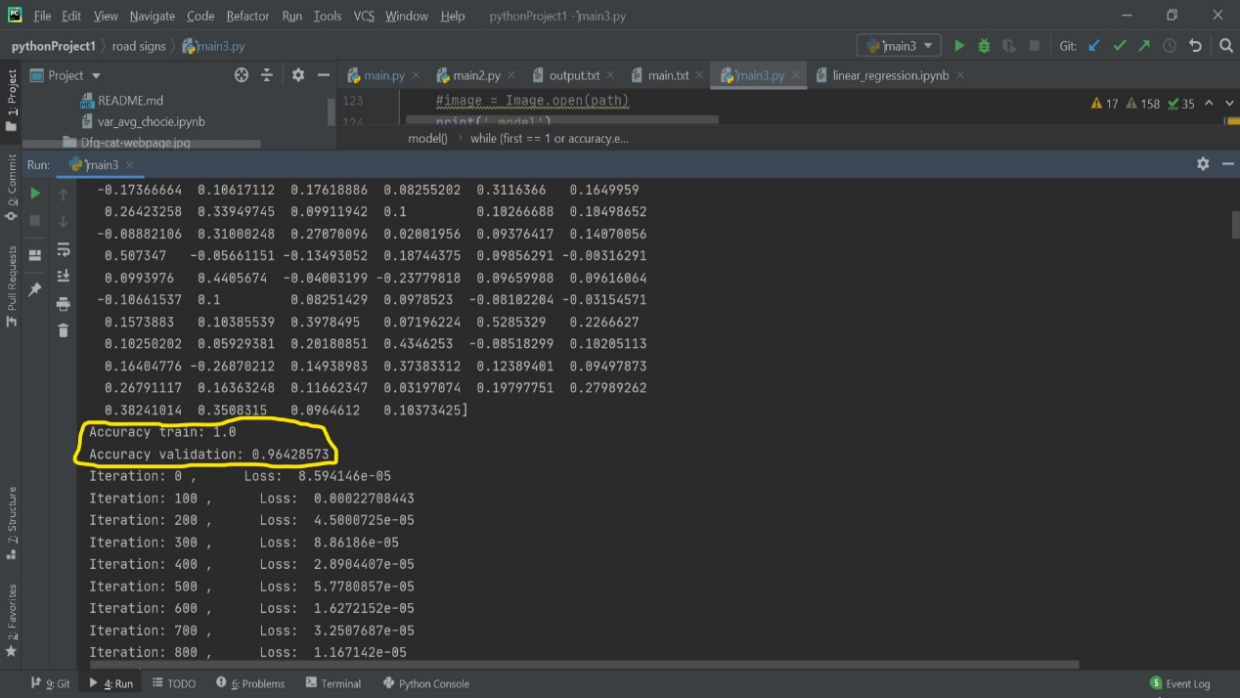**Neural Network with Adam optimizer**

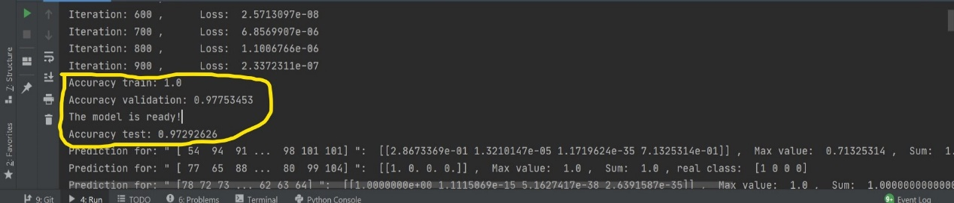 In the middle image the highest accuracy appears, then the accuracy begins to decrease.

The result with Neural Network with two hidden layers (200 neurons in the first layer and 100 neurons in the second layer) and Adam optimizer algorithm after 5000 iterations.